* **[How to create a promoted links list (PART1)](https://sharepoint.rackspace.com/learning/articles/Pages/SharePoint-2013--how-to-create-a-promoted-links-list-app-part-1.aspx)**

The Promoted Links app in SharePoint 2013 is a very simple and useful feature. The app displays links as icons or tiles on a web page once the web part is added.   I’m sure you can already think of several instances where this will be useful.  This is part 1 of 3, which will cover creating a Promoted Links list and creating a link.

1. From the home page of your SharePoint site on the Quick Launch click **Site Contents.**

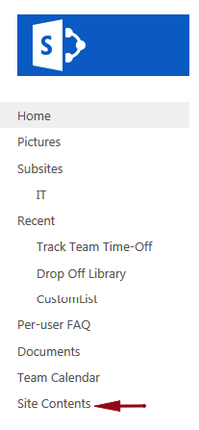

2. On the Site Contents page under Lists, Libraries, and other Apps click **add an app**.

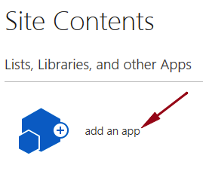

3. On the Your Apps page scroll down and click **Promoted Links.**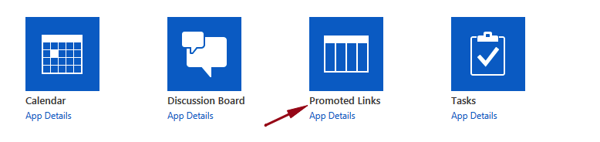

 4. In the Name section give it a name, for this example I will call mine “**PromotedIcons**”.

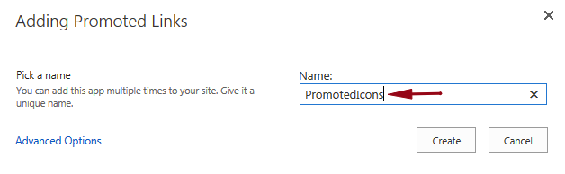

5. Click **Create**.  
https://sharepoint.rackspace.com/PublishingImages/Pages/sp2013%20how%20to%20create%20a%20promoted%20links%20list%20app%20part%201/promotedlink1-5.png

6. Back on the Site Contents page locate and click on your Promoted Links list, in this example “**PromotedIcons**.”



7. At the top of the page click **ITEMS** to expand the ribbon.

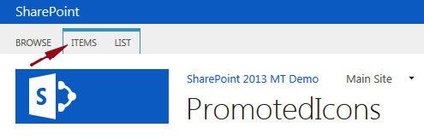

8. In the New section click **New Item**.

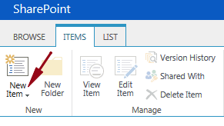

9. For this example I will enter the following information below:

* Title – **Company Tasks**
* Background Image Location – **https://scuba3.atrackspace.com/Pictures/TaskIcon.png** (Image stored in SharePoint Picture Library)
* Description – **Link to Team Tasks list.**
* Link Location – **https://scuba3.atrackspace.com/Lists/Team%20Tasks/AllItems.aspx**
* Launch Behavior – **In page navigation**
* Order – **1**

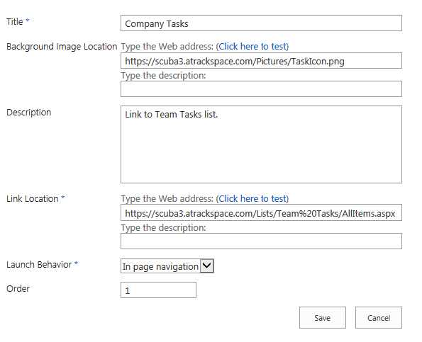

10. Review your information and click **Save**.

https://sharepoint.rackspace.com/PublishingImages/Pages/sp2013%20how%20to%20create%20a%20promoted%20links%20list%20app%20part%201/promotedlink1-10.png

11. You will see your new Promoted Link “**Company Tasks**” in the “PromotedIcons” list. 

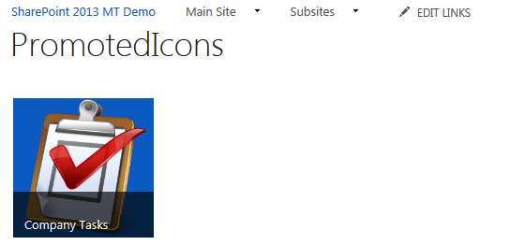

A few more notes on Promoted Links: If you hover over the icon you will see the description you entered in step 9 in the Background Image field.  If you click on the icon or tile you will be taken to the Link Location you associated it with in step 9 in the Link Location field. I hope you enjoyed and remember there are still 2 more parts; the SharePoint fun has just begun!